PCC 2.2

Typical Great Plains Release

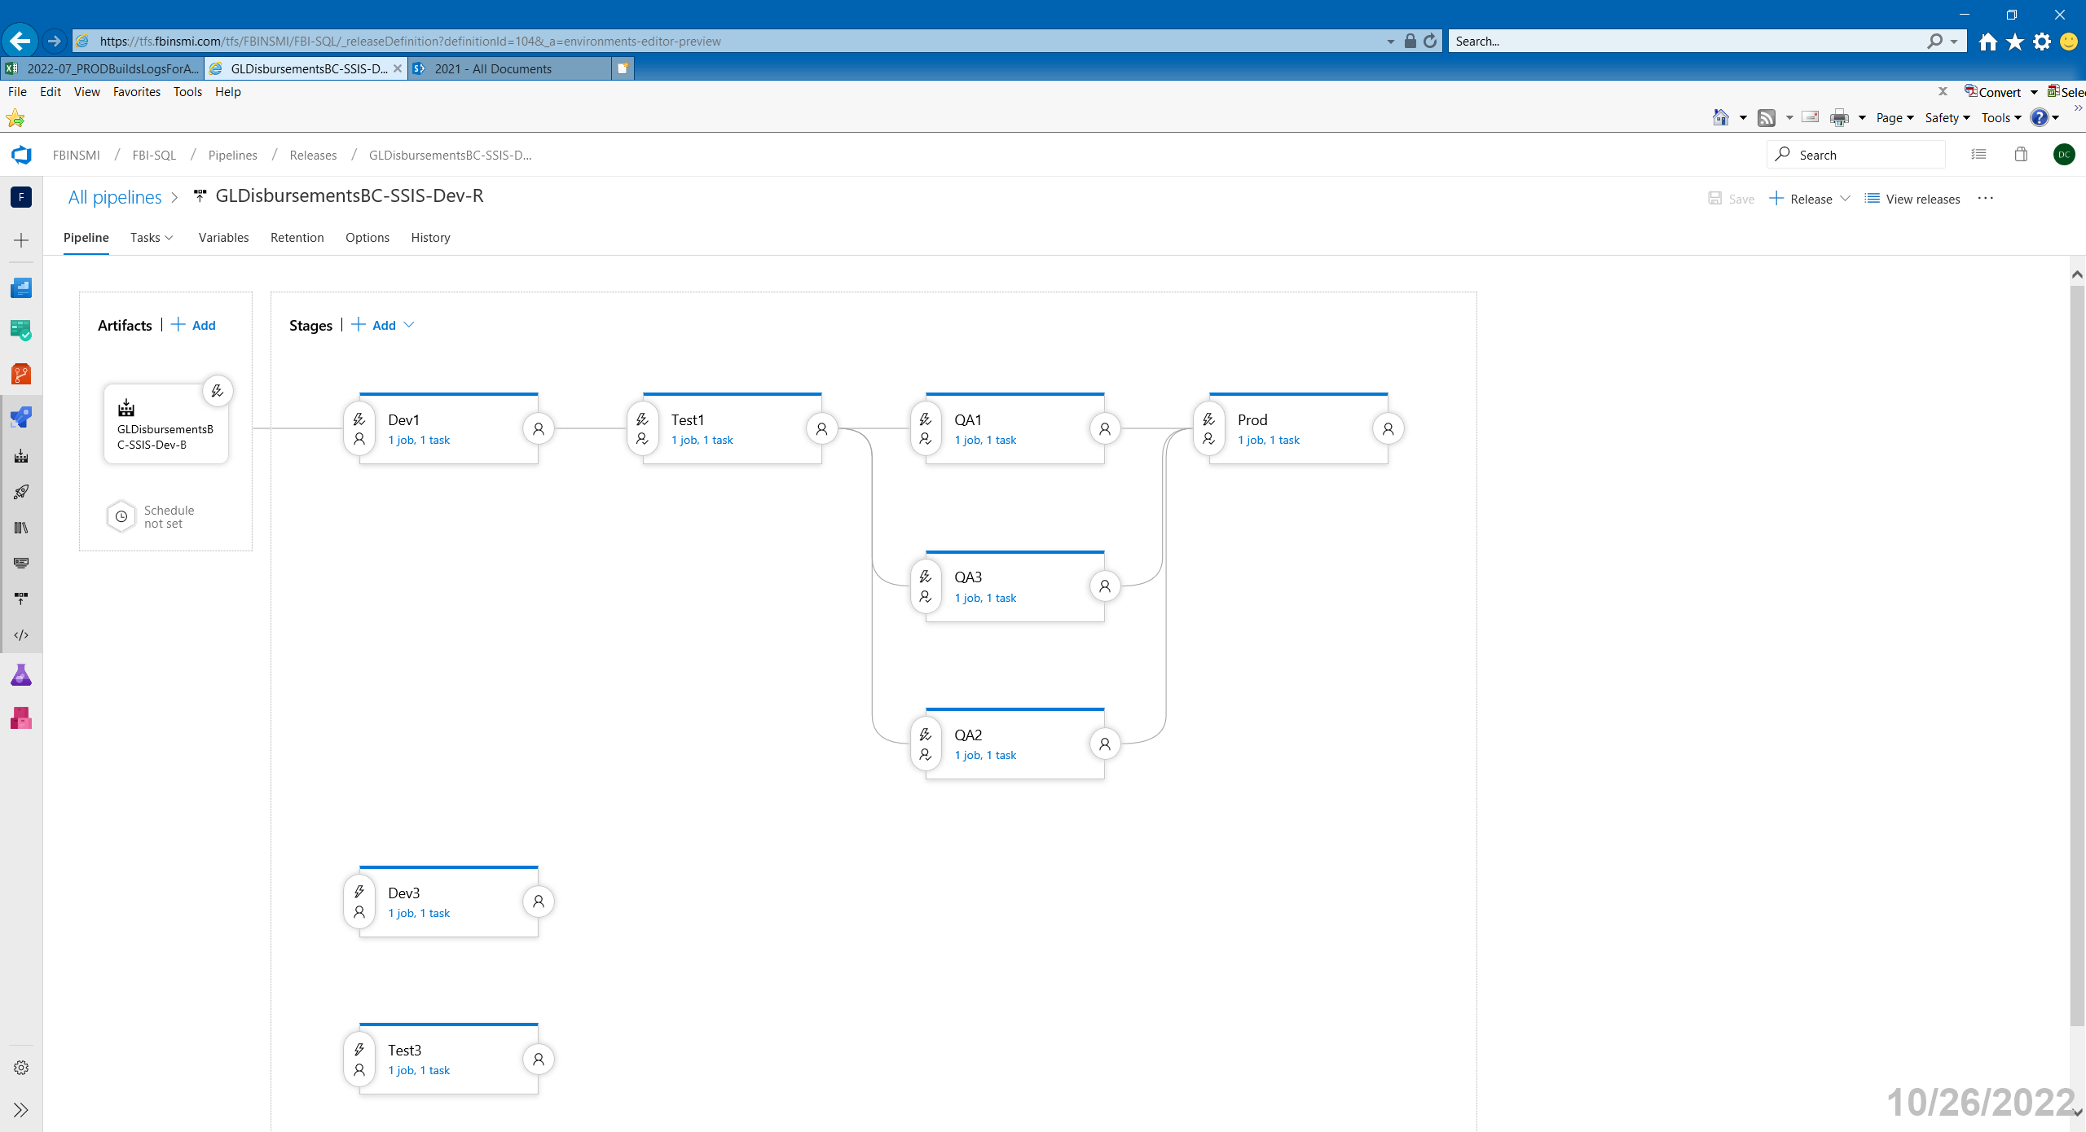

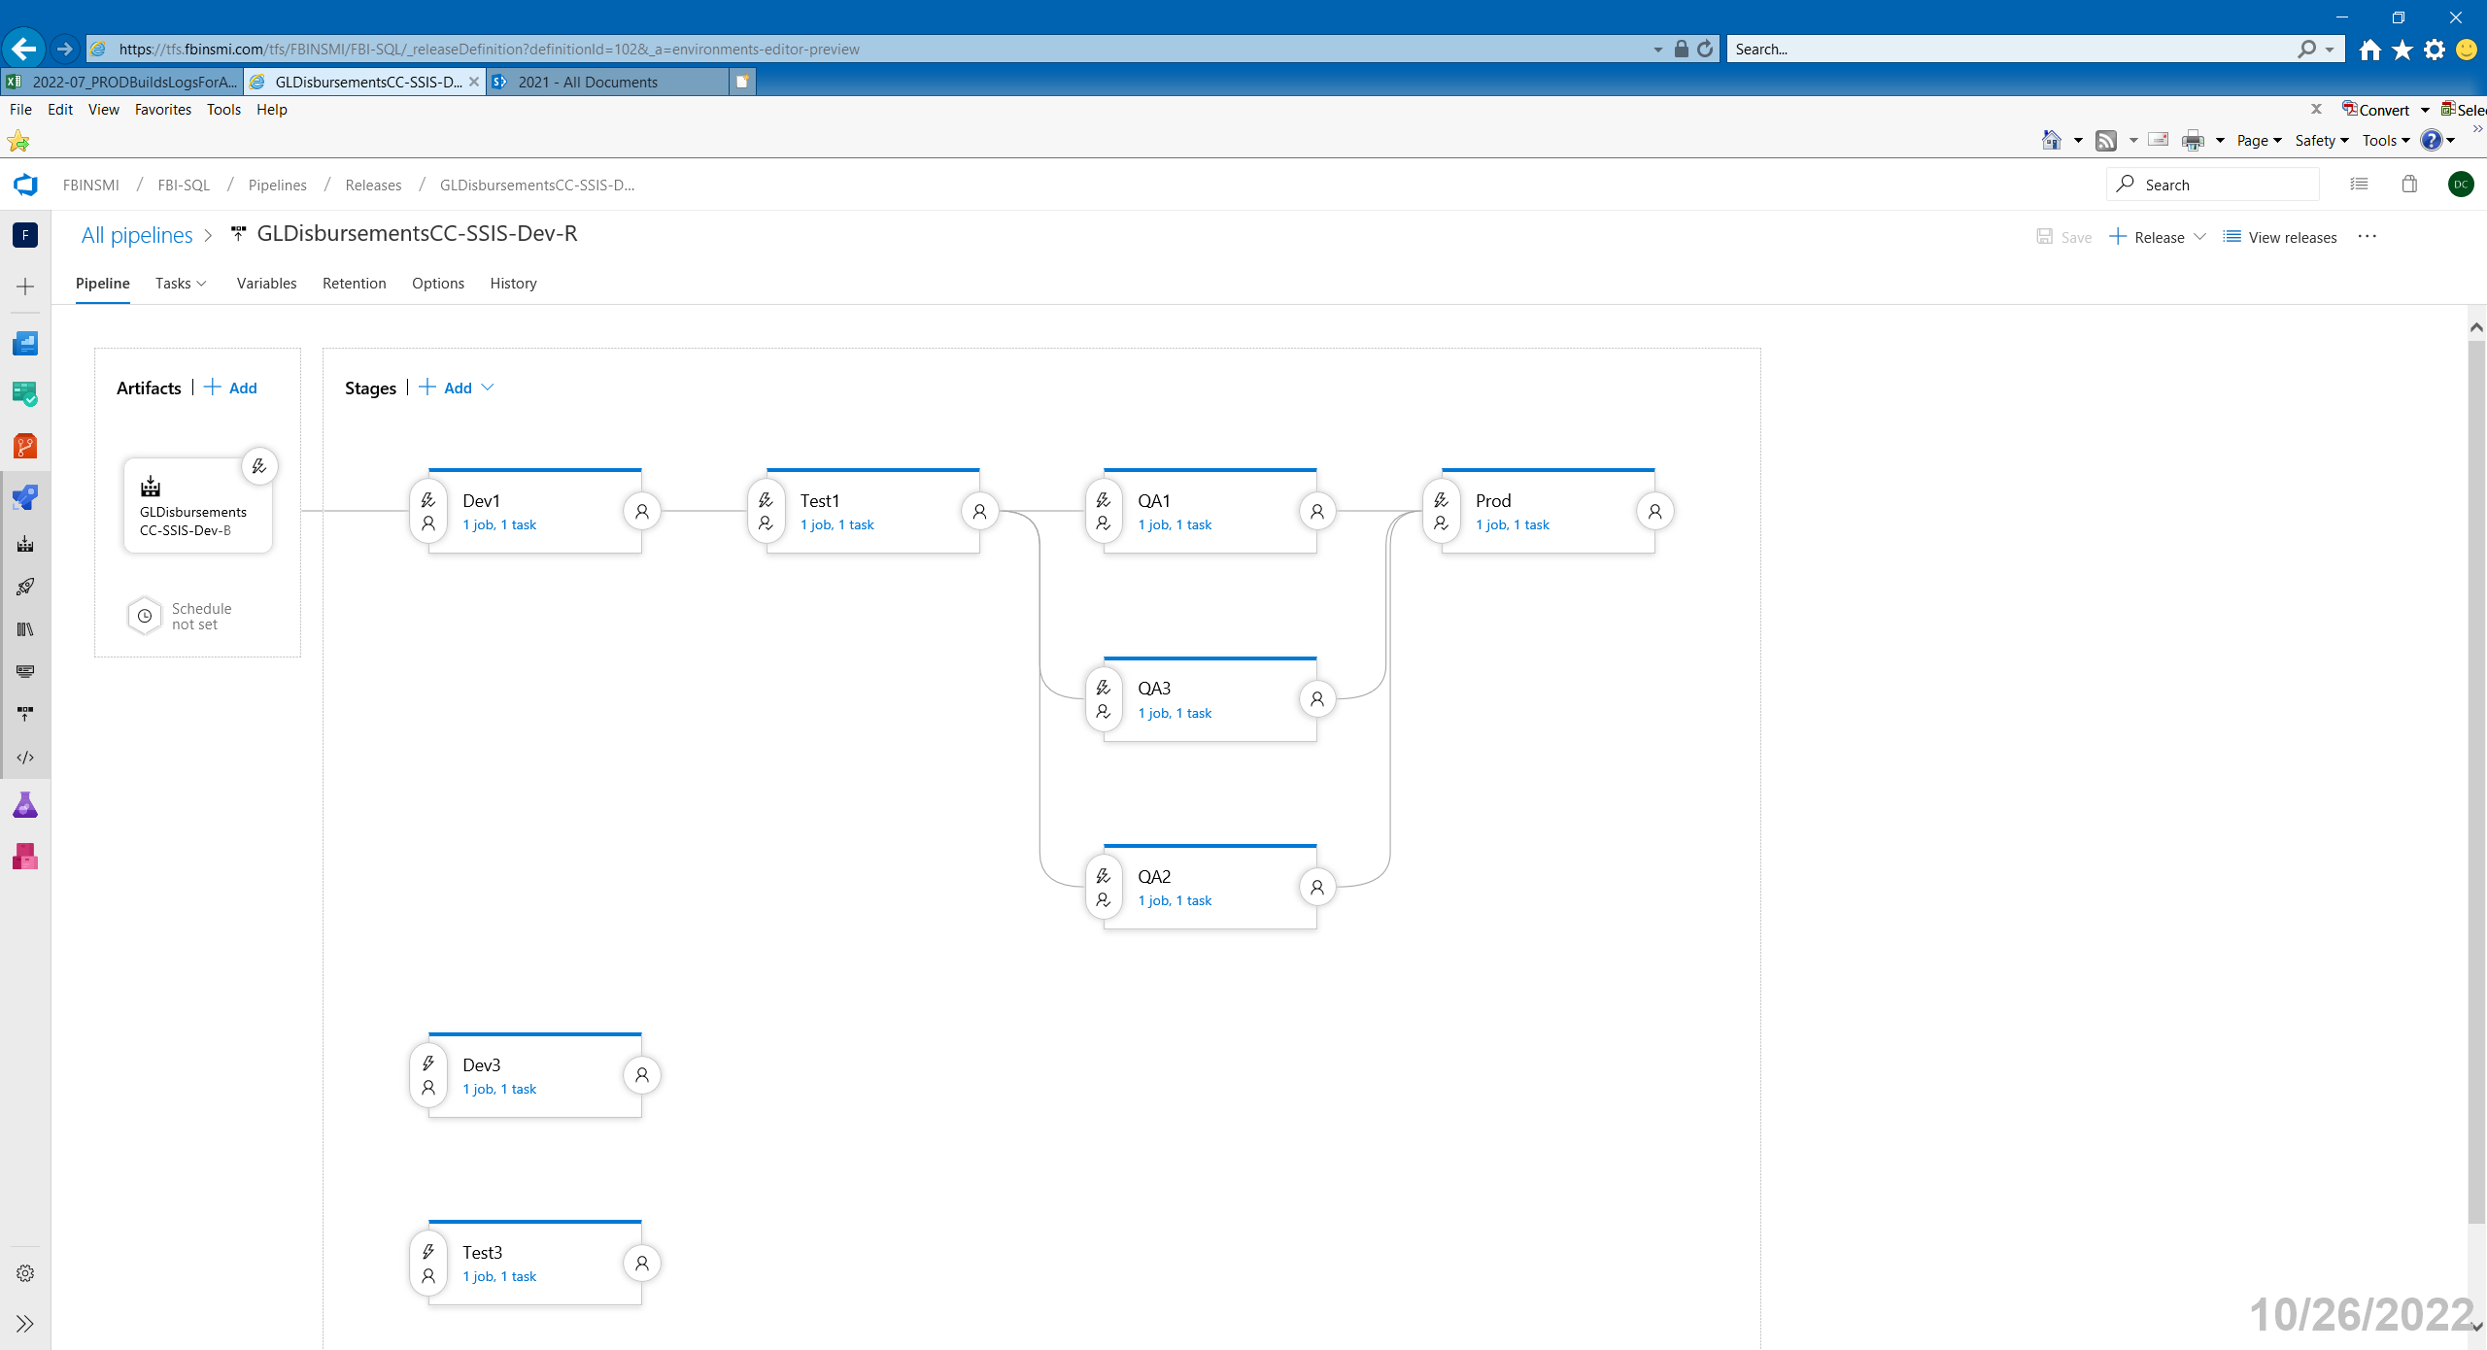

Typical GW Release

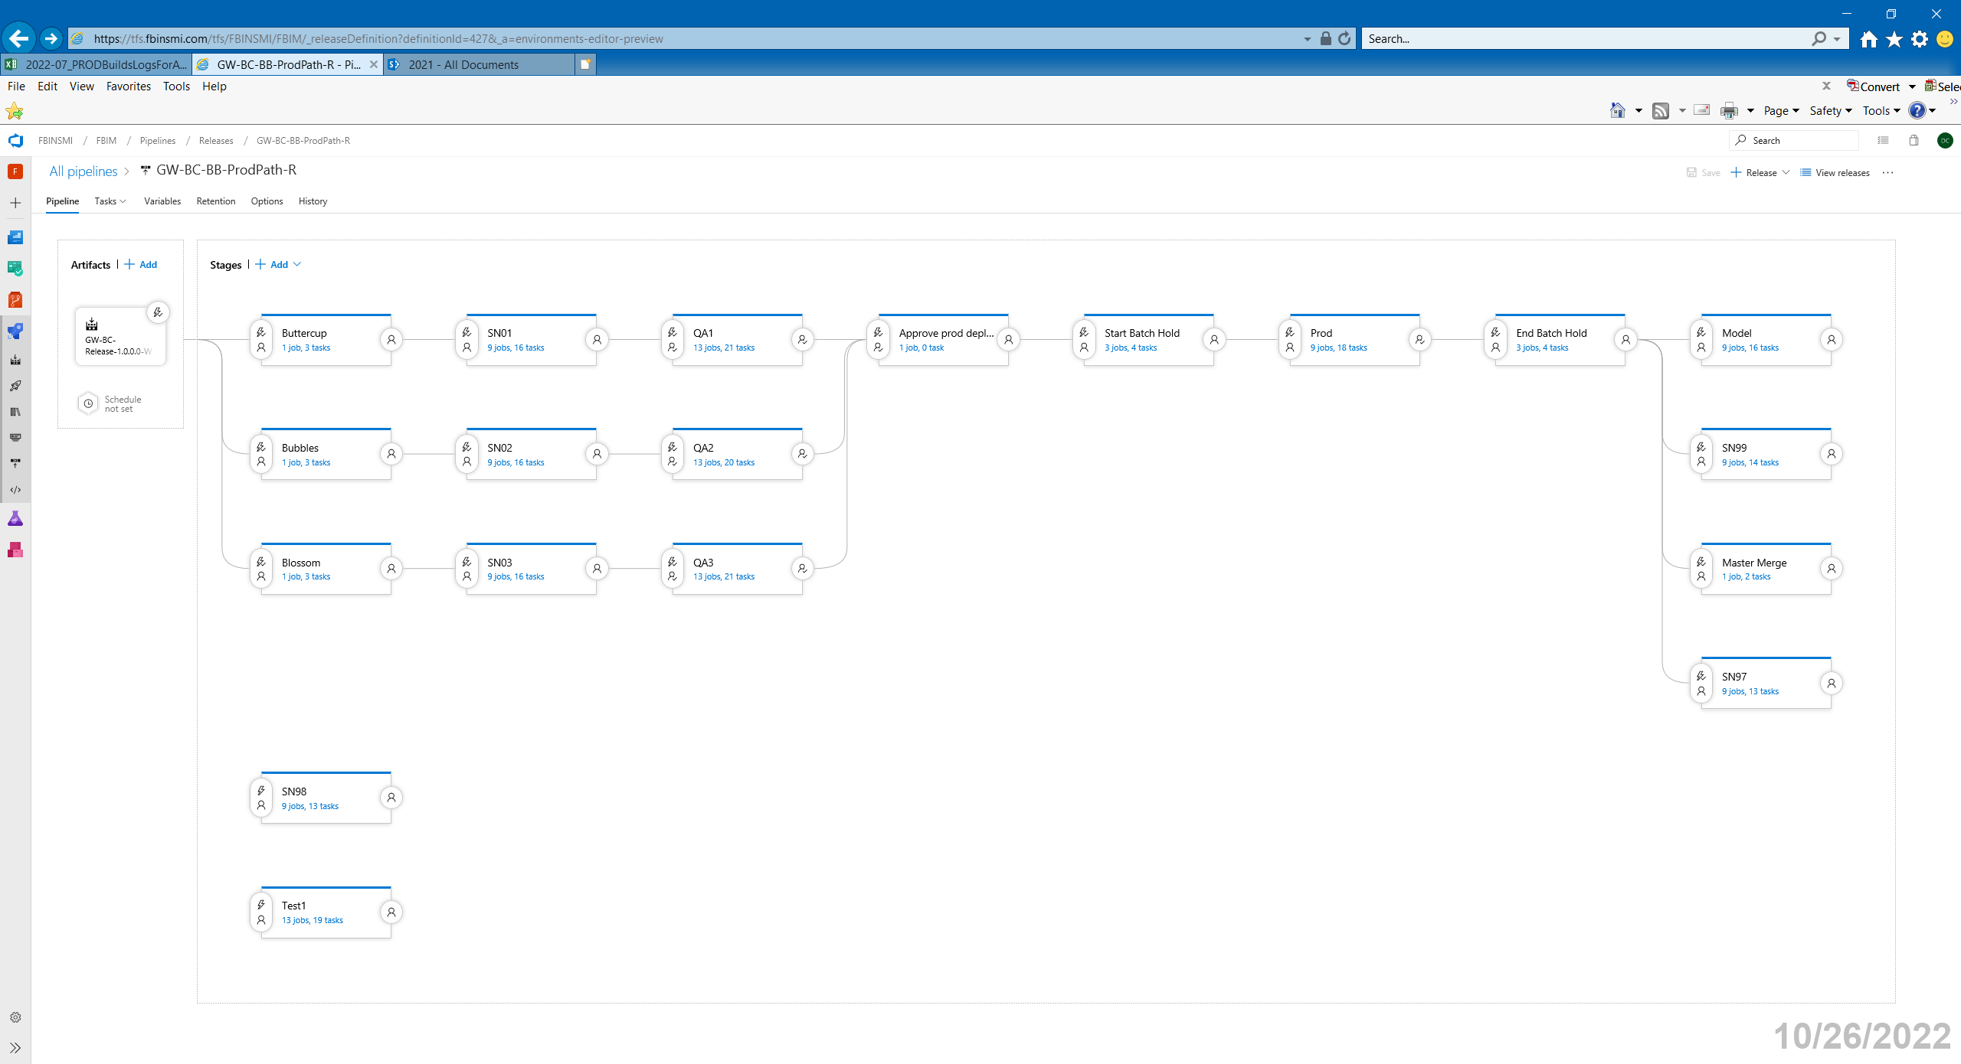

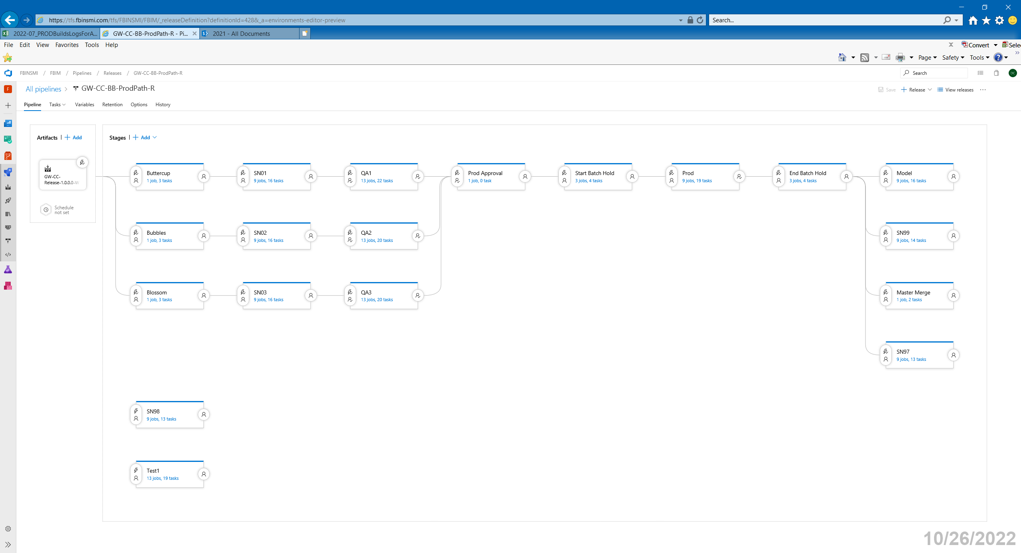

Versara Releases

Graphical user interface, text, application, email

Description generated with very high confidence

Graphical user interface, text, application, email

Description generated with very high confidence

Graphical user interface, text, application, email

Description generated with very high confidence

Graphical user interface, text, application, email

Description generated with very high confidence

ProCede Release

